Build and Release Management Lab Experiment 8

Name: Himanshu Dubey

Roll No: R171219013

SAP : 500075125

Branch: B.tech Cse devops

**Aim:** Create a maven project using Build Profile.

**Step 1:** Create simple maven project using CLI or Eclipse IDE and add a text file in the “\src\main” folder of the project.

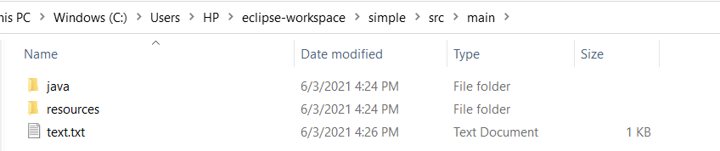

**Step 2:** Now open the “pom.xml” file of the project and add the following Build Profile:

<profiles>

<profile>

<id>coping</id>

<build>

<plugins>

<plugin>

<groupId>org.apache.maven.plugins</groupId>

<artifactId>maven-antrun-plugin</artifactId>

<version>1.1</version>

<executions>

<execution>

<phase>test</phase>

<goals>

<goal>run</goal>

</goals>

<configuration>

<tasks>

<echo>Copied Test1.txt</echo>

<copy file="src/main/Test1.txt" tofile="src/Test1.txt"/>

</tasks>

</configuration>

</execution>

</executions>

</plugin>

</plugins>

</build>

</profile>

</profiles>

**Step 2:** Now open the CLI, go the project folder containing the pom.xml and execute the following mvn command.

mvn test -Pcopying

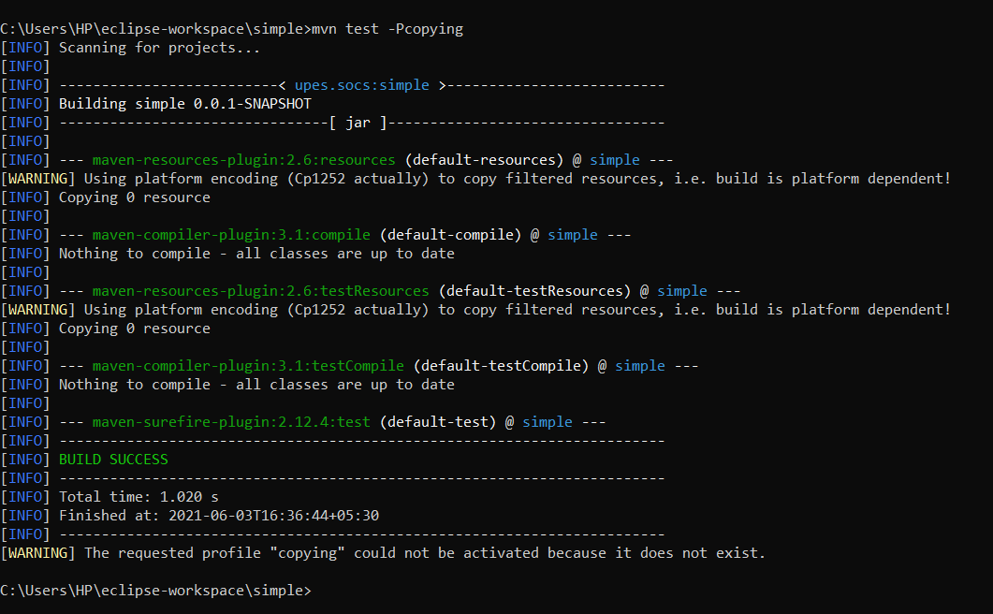

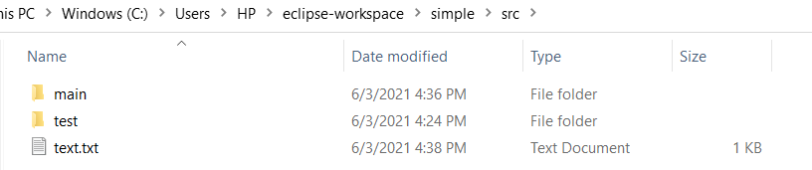**Step 3:** Now open the “\src” folder of the project and we can find the text file we created in “\src\main” folder copied into “\src” folder.

**Step 4:** We can also add Active Profiles in “settings.xml” file in which is present in C:\Users\<user_name>\.m2 folder. Open the file and add the following active profile:

<activeProfiles>

<activeProfile>copying</activeProfile>

</activeProfiles>

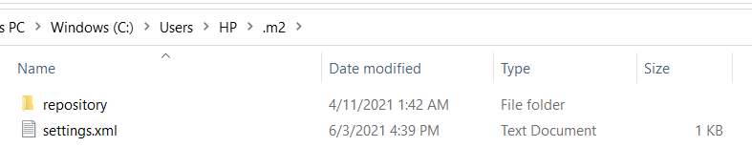

Now run we can run the above mvn command without the help of the argument -P<profile> and simply write the following:

mvn test

**Result:** Hence we successfully created and build a maven project with Build Profiles.